CBE Alarms and Response Procedure

Alarm | Where is it? | What does it mean? | What do I do?
Fridge/Freezer | On panel on the front of the fridge or freezer. | There has potentially been a power cut or a fault with the fridge or freezer. Alternatively the device has been left open too long and the temperature has fluctuated. | Look for signs of a puddle on the floor that may indicate the freezer has begun to defrost. Look at the display panel ( if it has one ) which may tell you the history of what has occurred. Open the fridge and freezer to check items are still cold/frozen. If they are shut the door and report the issue to Carolyn and Kul. If items have begun to defrost and the freezer is no longer working transfer items to another freezer and alert Carolyn and Kul and other lab users through lab users E-mail system. Detail what has happened and where items have moved to. Complete the Corrective Action and Preventative Action report form found on the CBE LEARN page) to log and investigate the incident.  If freezer contains HTA material ( there will be a sign on the door) please alert the owner of the material and Carolyn and Kul.
Equipment | On equipment itself | There has been an error while equipment is in operation. This could be due to a power cut or it has run out of a reagent it requires. | Contact the responsible person for the equipment or whoever has been using the equipment.  Notify Carolyn and Kul
Oxygen Monitor | Devices can be found in all areas where liquid nitrogen is in use. | i)Fault with the monitor  ii)Depletion of oxygen in the room. | Evacuate the area and prevent anyone else entering.  Report to Carolyn and Kul or safety officer.  Do not re-enter the area until safe to do so.
Temperature Monitoring | The display panel is in the internal corridor on the wall opposite the first change . | Most fridges, freezers and all cryostorage units are attached to the temperature monitoring system. If the temperature fluctuates from set ranges the alarm will sound on the display panel ( Pictured below).  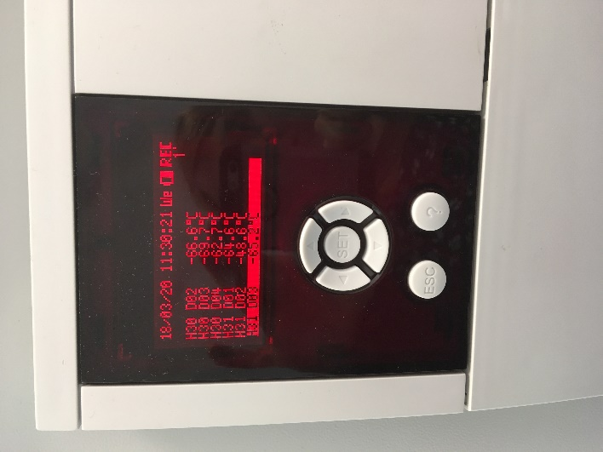 | i)Go to the display panel and review which device is alarming. This should be highlighted. Mute the alarm by pressing the button. Proceed then to check the affected device to see what the issue is. If a fault cannot be detected please communicate this anyway to Carolyn and Kul along with which alarm it was for. There is a list of devices and alarm numbers next to the display panel for reference. ( see below). If an issue is found please respond accordingly ( e.g closing the door firmly if fridge door has been left open) . If a freezer is broken and items defrosted please transfer items inside to another back up device and alert Carolyn and Kul. Please also communicate with all lab users as to where items have been moved to.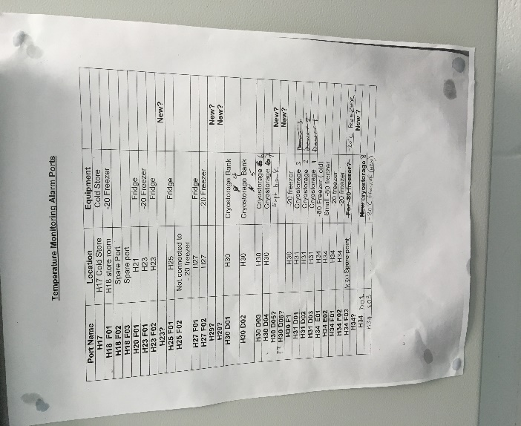  Sometimes we have false alarms for the cryostorage units and the error message that you see if ‘EEE’ as if it is no longer connected. This needs to be investigated regardless by going to check the cryostorage is connected to the system and the lid is in place.
Air handler unit for the CTMF | In the CBE office near the sink. | There has been a disruption of power to the air handling unit for the CTMF area. The green button tells us it is ok and the red button tells us of a fault to the extract or supply.  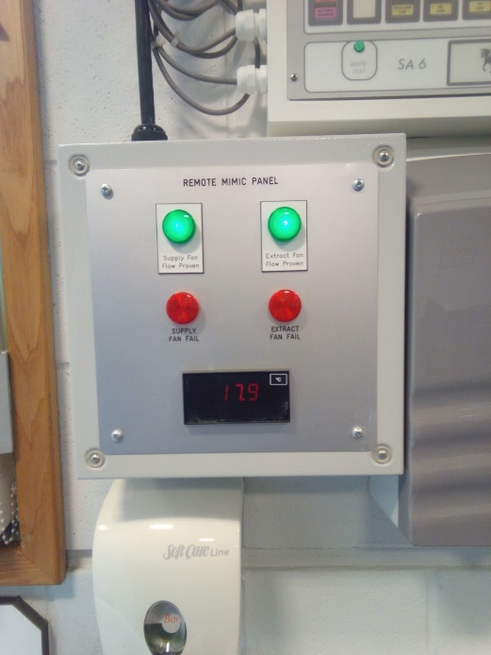  There is no display panel for issues with the air handler to the main lab but you will know if there is an issue as there will be a noisy atmosphere and the doors to the lab will not close properly. | Contact Carolyn and Kul or Facilities Management directly to report.  If the issue is with the main lab no HG2 ,GMO work or work with hazardous chemicals can be done until the fault has been rectified.  Carolyn and Kul must be notified so instructions can be communicated to all.
Gas cylinder usage | In the CBE office near the sink | A cylinder of Co2, N2 or O2 has run out and requires exchanging for a new one as soon as possible. This system has an automatic change over system so the other cylinder in the pair will kick in to keep the supply running. However, this alarm will continue until a new cylinder is hooked up. This is essential for the system to work. There is no need to panic if you see this but you do need to notify someone.  The display panel indicates which type of gas cylinder requires replacing.  There is a mute button for the alarm but NEVER mute it without notifying someone that the alarm has been raised. If two full cylinders are not in the system the incubators in the facility will not be supplied with Co2 meaning the cell cultures will perish.  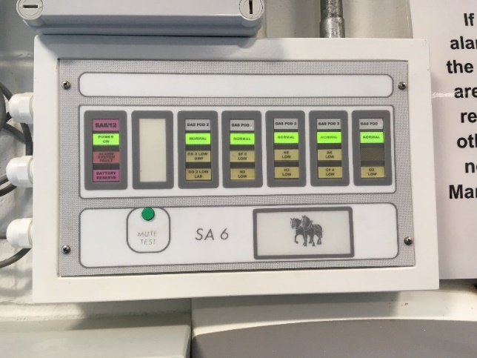 | If you are fully trained to change cylinders go ahead and do so. Please notify Eleri of the barcode numbers of the cylinders exchanged. If you are not trained or not confident do not proceed.  If you are not trained - Notify "cbe-lab-support@lists.lboro.ac.uk" so that this can be dealt with by one of the support team.

