CBE FIRST AIDERS

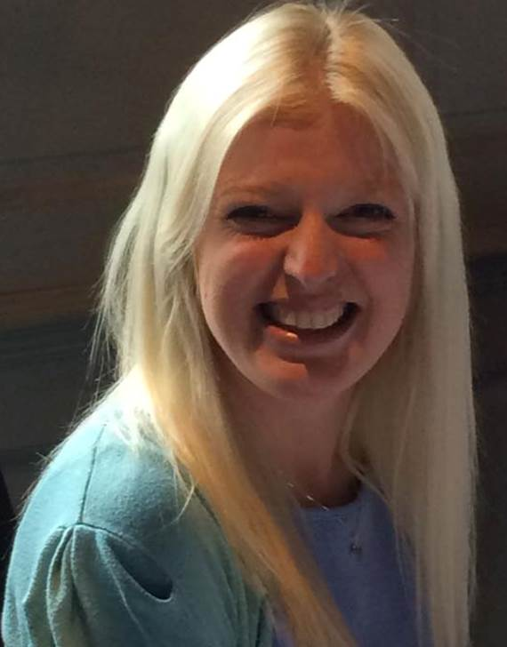

Dr.Sammy Wilson

Lecturer

S.Wilson2@lboro.ac.uk

Jon Harriman

Technician

j.harriman@lboro.ac.uk

Jen Bowdrey

Technician

j.bowdrey@lboro.ac.uk

Dr. Katie Glen

Research Associate

k.e.glen@lboro.ac.uk

CBE FIRE MARSHALS



Jon Harriman

Technician

j.harriman@lboro.ac.uk

Jen Bowdrey

Technician

j.bowdrey@lboro.ac.uk

Carolyn Kavanagh

Experimental Officer

c.l.kavanagh@lboro.ac.uk

Kulvinder Sikand

Experimental Officer

k.sikand@lboro.ac.uk

Jen Bowdrey.

Technician.

j.bowdrey@lboro.ac.uk