*Centre for Biological Engineering*

**2nd CBE TEAM Meeting**

**Tuesday 8th June 2021**

**10am -11am**

**Microsoft Teams**

**Present:**

**Carolyn Kavanagh (CK)**

**Kulvindar Sikand ( KS)**

**Karen Coopman ( KC)**

**Elizabeth Ratcliffe ( ER)**

**Jon Harriman ( JH)**

**Katie Glen ( KG)**

**Jenna Davis ( JD)**

**Nishant Joglekar (NJ)**

**Ria Toumpaniari ( Ria T)**

**Catherine Beltran- Rendon ( CBR)**

**Laura Erdos ( LE)**

**Hugo Bell ( HB)**

**Apologies:**

**Jen Bowdrey( JB)**

__________________________________________________________________

**Agenda**

1. Review of previous actions ( combined from lab leaders/lab users meeting).

2. Facility Issues

3. Upcoming facility maintenance

4. Training Requirements

5. Safety/HTA

6. CAPA review and update

7. A.O.B

1. **Review of previous actions (Lab Leader/Lab User combined)**

|  |  |  |  |
| --- | --- | --- | --- |
|  | | | |
| **No.** | **Action** | **Due Date** | **Responsibility/status** |
| **Action**  **CTM01/01** | JB to send an E-mail to lab users regarding Claiming chemicals and to complete Chemical Waste disposal for by end of March | March 2019 | JB  Ongoing  New kickstart to CBE Chemical Management strategy. JB has re-audited and will be sending out lists of Chemicals requiring COSHH and populating spreadsheet. |
| **Action**  CTM01/02 | KS to contact -80 Freezer engineer for advice about pools of water. | Nov 2020 | KS  Ongoing  Service of all -80 Freezers is progressing. Two remaining ones are due 16th June and 7th August 2021. Lab users asked to move items ahead of these dates so that -80 freezers can be defrosted before the service .Good opportunity to dispose of items no longer required. Engineer has said pools of water are due to humidity. *KG suggested looking at options for absorbent mats to reduce pools of water as This needs to be addressed.* |
| **Action**  **CTM01/03** | KS and CK to set up new temperature monitoring system | Nov 2020 | CK/KS  Ongoing  Process needs to formalised for out of hours via txt service. |
| **Action**  **CTM01/06** | KS and JB to keep a list of cell types which have been PCR tested and to periodically send this out to everyone making it obvious which cells requiring testing. | April 2019 | KS/JB  Closed.  Mycoplasma testing has restarted. Jen records cell lines tested each time. |
|  | KS to write an SOP covering what to do in the event of an air handler failure. | July 2019 | KS  Ongoing  Needs to be sent to Keven for approval. |

|  |  |  |  |
| --- | --- | --- | --- |
| **Actions arising from CBE Team Meeting 9th February 2021** | | | |
| **No.** | **Action** | **Due Date** | **Responsibility** |
| **Action CTM01/01** | CK to put together a head count of CBE users to circulate as part of the meeting. | Feb 21 | CK/KS  Complete |

1. **Facility Issues**
2. KC noted that she was pleased to see the return of the fortnightly ordering system to help focus minds and streamline the ordering.
3. CK commented that herself and Jen had performed a cryostorage audit and found a few discrepancies. There was a discussion around the use of Pro-curo and the database and the need to move to one system. CK commented that some material in the cryostorage units was not on Pro-curo and therefore this was the reason for the two systems. The running of the two systems has been going on for admittedly too long but was due to lack of resource and other priorities taking over. CK will discuss with Jen offline to see if an ‘archive’ system can be maintained and Pro-curo become the predominant system adopted.
4. KS commented that the pipette clinic was due in August and asked for thoughts on the location of where this could take place. It was agreed that on the bench in H34 would be suitable.
5. CK asked for ideas and suggestions from the group to co-ordinate the housekeeping better. CK commented that she appreciated people had other priorities ( research) and that the numbers were low in the facility to share the duties. .JD commented that as she would be leaving soon so H29 and H25 would soon have less cover. There were discussions around different approaches to housekeeping including doing what was needed before lab work started, having set times to come in to do the clean together and returning to a more team ethic of people doing what is required as they see it needs doing ( regardless of who’s turn it was)

. These were some suggestions :

1. Merging groups to cover the shared areas ( more people on duty but more frequently)
2. ‘Mothballing’ certain areas that are not used currently while ensuring that equipment is maintained and switched on periodically. Once the area is used again a clean is done and maintained by those working in there.
3. Adjusting or prioritising the tasks
4. Encouraging people to notify and ‘swap’ duties if they have a particular busy week.

CK to review suggestions and amend for next rota.

1. **Upcoming facility maintenance**

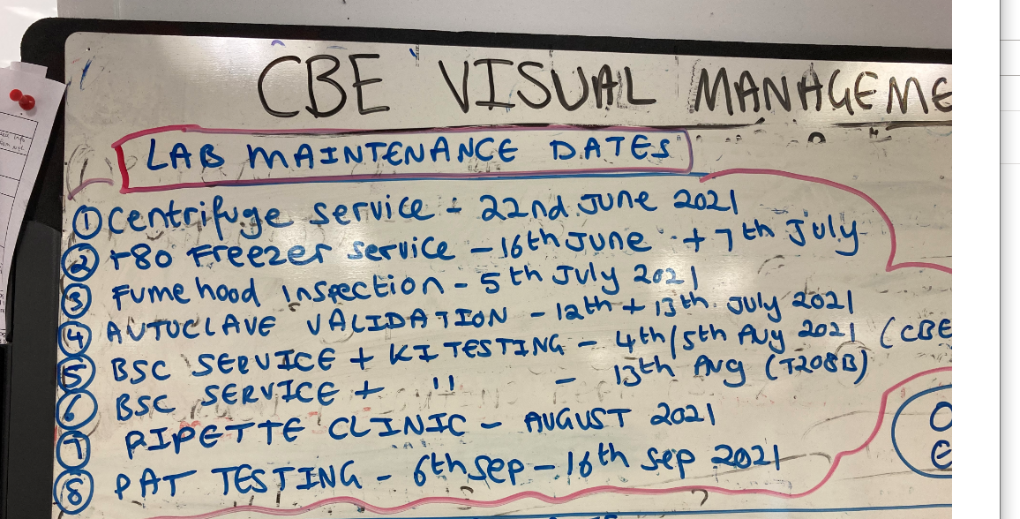

1. **Training Requirements**

None scheduled at the moment. CK asked for groups to get in touch in advance for new starters**.**

1. **Safety/HTA**
2. .**CAPA review and update**

None

1. **A.O.B**
2. CK reminded lab users about the deep clean of the lab spaces during June/July. Users have a large timeframe to work with that fits around research work.
3. CK commented that she was still looking for volunteers to help with the work experience student on the 28th and 29th June.

**Summary of Actions.**

|  |  |  |  |
| --- | --- | --- | --- |
| **Actions arising from CBE Team Meeting 8th June 2021** | | | |
| **No.** | **Action** | **Due Date** | **Responsibility** |
| **Action CTM02/01** | KS and CK to look at absorbent mats for -80 freezers. | Aug 2021 | CK/KS |
| **CTM02/02** | CK and JB to review the cryostorage database and Pro-curo with the view to moving to one system.Consider an ‘archive’ system. | July 2021 | CK/JB |
| **CTM02/03** | CK to review and amend housekeeping system | Aug 2021 | CK/KS |

**Date of next meeting:**

Date: Tuesday 17th August 2021

Time: 10am – 11am.

Venue: Microsoft Teams

1)KS commented that the BSC inspection and KI testing would be done by a different contractor from previous years. The new LEV DAP was also unclear.

2)CK commented that herself and Jen had performed a HTA traceability audit in May 2021. There were a few issues with samples being logged on Pro-curo but were not in the cryobanks and one in the wrong position. Some issues surrounding updating Pro-curo but the relevant lab users had been contacted.

Appendix 1: **CBE Head count**

.

**May Head count**

|  |  |  |  |  |
| --- | --- | --- | --- | --- |
| **Name** | **Supervisor** | **School** | **Level** | **Lab** |
| Katie Glen | Rob Thomas | Wolfson | RA | H21/ABS |
| Rob Thomas |  | Wolfson | Professor | H21/ABS |
| Jon Harriman | Rob Thomas | Wolfson | Research Technician | H21/ABS |
| Catherine Beltran -Rendon | Rob Thomas | Wolfson | PhD | H21 |
| Maryam Shariatzadeh | Rob Thomas | Wolfson | RA | H21 |
| Laura Erdos | Rob Thomas ( ABS staff ) |  | ABS Staff | H21/ABS |
| Jen Bowdrey | Karen Coopman | AACME | Technician | H23 |
| Nishant Joglekar | Karen Coopman/Elizabeth Ratcliffe | AACME | PhD | H23 |
| Jenna Davis | Elizabeth Ratcliffe | AACME | PhD | H25/H29 |
| Hugo Bell | Carmen Torres | Wolfson | PhD | H23 |
| Praveen Kavari | Sourav Ghoush | Wolfson | PhD | T208b ( Wolfson) |
| Jakub Nasterski | Sourav Ghoush | Wolfson | PhD | H34/T208b |
| Ann Lawrence | Sourav Ghoush | Wolfson | PhD | T208b ( Wolfson) |
| Sammy Wilson |  | Wolfson | Lecturer | H25/H23 |
| Fern Ellis | Sammy Wilson | Wolfson | Part C | H25/H23 |
| Ben Fisher | Sammy Wilson | Wolfson | Part C | H25/H23 |
| Ria Toumpaniari | Sotiris Korossis | Wolfson | RA | H25/H27/H23 |
| Maria Pavlidou | Sotiris Korossis | Wolfson | PhD | H25/H27 |
| Michelle Magee | Karen Coopman | AACME | UG | H23 |
| Alexandros Englezakis | Alexandra Stolzing | Wolfson | RA | H25 |
| Luqmaan Khan | Elizabeth Ratcliffe | AACME | UG | H29 |
| Harris Sheikh | Karen Coopman | AACME | UG | H23 |